**LEMBAR PROGRES**

**UKK 2021 - Aplikasi Pembayaran SPP**

**NIS : 195051289065**

**NAMA : Ryan Adi Saputra**

**KELAS : XII RPL A**

**E-MAIL :** **riyanadi552@gmail.com**

**PROGRES KE : 2**

**KETENTUAN UMUM :**

1. Setiap progres, wajib menyertakan kode program (*source code*) dan print screen hasil secara lengkap
2. Wajib melakukan progres minimal 5 Kali sebelum tanggal 19 April 2021
3. Untuk ikut UKK wajib menyelesaikan 75% projek

**KETENTUAN TEKNIS :**

* Convert Lembar Progres ini ke dalam format **PDF (.pdf)**, untuk di upload di **Google Form yang telah disediakan**
* Ganti nama file pdf dengan format: **NoAbsen_Nama_Kelas_ProgresKe**

**(contoh : 01_Andi Ronaldo_XII RPL B_1)**

* Ukuran file maksimal : **3 MB**

# HASIL PROGRES

# Pada progress ke-2 ini saya, telah menyelesaikan crud kelas dan pembenahan pada bagian crud petugas, serta login - logout pada 3 aktor beserta halamannya. Untuk crud spp dan siswa akan saya masukkan ke progress ke-3. Sekian dan terimakasih.

# Kode program :

1. Controller Auth.php

<?php

defined('BASEPATH') OR exit('No direct script access allowed');

/**

 * author ryanadi

 */

*class* Auth extends *CI_Controller* {

    public *function* __construct()

    {

*parent*::__construct();

        $this->load->model('M_Admin');

        $this->load->library('form_validation');

    }

    public *function* index()

    {

        $this->form_validation->set_rules('username', 'Username', 'required|trim' );

        $this->form_validation->set_rules('password', 'Password', 'required|trim' );

        if ($this->form_validation->run() == false) {

            if($this->session->userdata('userid') == null) {

                $data['title'] = "Preparation SPP";

                $data['app'] = "Bayar SPP";

                $this->load->view('login/login_header', $data);

                $this->load->view('login/login');

                $this->load->view('login/login_footer');

            } else {

                redirect('dashboard');

            }

        } else {

            $this->_login();

        }

    }

    private *function* _login()

    {

        $username = $this->input->post('username');

        $password = $this->input->post('password');

        $user = $this->M_Admin->getUsername($username);

        $nisn = $this->M_Admin->getNisn($username);

            if ($user){

                if($user['level'] == 'Administrator' || $user['level'] == 'Petugas') {

                    if ($user['status'] == 1){

                        if (password_verify($password, $user['password'])){

                            $data = [

                                'userid' => $user['id_petugas'],

                                'username' => $user['username'],

                                'nama_petugas' => $user['nama_petugas'],

                                'level' => $user['level'],

                                'status' => $user['status'],

                            ];

                            $this->session->set_userdata($data);

                            redirect('dashboard');

                        }else{

                            $this->session->set_flashdata('message', '<div class="alert alert-danger mx-auto alert-dismissible fade show" role="alert">Coba lagi!! Password salah!!<button type="button" class="close" data-dismiss="alert" aria-label="Close"><span aria-hidden="true">&times;</span></button></div>');

                            redirect('auth');

                        }

                    }else{

                        if (password_verify($password, $user['password'])){

                            $this->session->set_flashdata('message', '<div class="alert alert-danger alert-dismissible fade show mx-auto" role="alert">Akun Anda telah diblock oleh Administator!!<button type="button" class="close" data-dismiss="alert" aria-label="Close"><span aria-hidden="true">&times;</span></button></div>');

                            redirect('auth');

                        }else{

                            $this->session->set_flashdata('message', '<div class="alert alert-danger mx-auto alert-dismissible fade show" role="alert">Coba lagi!! Password salah!!<button type="button" class="close" data-dismiss="alert" aria-label="Close"><span aria-hidden="true">&times;</span></button></div>');

                            redirect('auth');

                        }

                    }

                }else{

                    redirect('auth');

                }

            }elseif($nisn){

                if ($password == $nisn['nisn']){

                    $data = [

                        'userid' => $nisn['nisn'],

                        'username' => $nisn['nis'],

                        'nama_petugas' => $nisn['nama_siswa'],

                        'level' => 'Siswa',

                        'status' => 1,

                    ];

                    $this->session->set_userdata($data);

                    redirect('dashboard');

                }else{

                    $this->session->set_flashdata('message', '<div class="alert alert-danger mx-auto alert-dismissible fade show" role="alert">Coba lagi!! Password salah!!<button type="button" class="close" data-dismiss="alert" aria-label="Close"><span aria-hidden="true">&times;</span></button></div>');

                    redirect('auth');

                }

            }else{

                $this->session->set_flashdata('message', '<div class="alert alert-danger mx-auto alert-dismissible fade show" role="alert">Akun tidak terdaftar!! <button type="button" class="close" data-dismiss="alert" aria-label="Close"><span aria-hidden="true">&times;</span></button></div>');

                redirect('auth');

            }

    }

    public *function* logout()

    {

        $this->session->sess_destroy();

        $this->session->set_flashdata('message', '<div class="alert alert-success mx-auto alert-dismissible fade show" role="alert">Berhasil Logout!<button type="button" class="close" data-dismiss="alert" aria-label="Close"><span aria-hidden="true">&times;</span></button></div>');

        redirect('auth');

    }

}

?>

1. Model M_Admin.php

<?php

defined('BASEPATH') or exit('No direct script access allowed');

/**

 * author ryanadi

 */

*class* M_Admin extends *CI_Model*

{

    public *function* __construct()

    {

*parent*::__construct();

    }

    //cek login

    public *function* getUsername($username)

    {

        return $this->db->get_where('petugas', ['username' => $username])->row_array();

    }

    public *function* getNisn($nisn)

    {

        return $this->db->get_where('siswa', ['nisn' => $nisn])->row_array();

    }

    //datauser / session

    public *function* datauser()

    {

        return $this->db->get_where('petugas', ['username' => $this->session->userdata('username')])->row_array();

    }

    //tambah petugas

    public *function* tambah_petugas()

    {

        $data = [

            'username' => htmlspecialchars($this->input->post('username', true)),

            'nama_petugas' => htmlspecialchars($this->input->post('nama_petugas', true)),

            'password' => password_hash($this->input->post('password'), PASSWORD_DEFAULT),

            'level' => 'Petugas',

            'status' => 1,

        ];

        $this->db->insert('petugas', $data);

    }

    //ambil data petugas

    public *function* getDataPetugas($id)

    {

        return $this->db->get_where('petugas', ['id_petugas' => $id])->row_array();

    }

    //ambil data petugas

    public *function* getPetugas($limit = null, $start = null, $count = true, $cari = null)

    {

        $this->db->select('*');

        $this->db->from('petugas');

        if ($cari != null) {

            foreach ($cari as $keyc => $valuec) {

                $this->db->or_like($keyc, $valuec);

            }

        }

        if ($count) {

            return $this->db->count_all_results();

        } else {

            $this->db->limit($limit, $start);

            $query = $this->db->get();

            if ($query->num_rows()  > 0) {

                return $query->result_array();

            }

        }

        return array();

    }

    //count data petugas

    public *function* countPetugas()

    {

        return $this->db->get('petugas')->num_rows();

    }

    //ubah petugas

    public *function* ubah_petugas($data, $where)

    {

        return $this->db->where($where)->set($data)->update('petugas');

    }

    //delete petugas

    public *function* delete_petugas($id)

    {

        return $this->db->delete('petugas', ['id_petugas' => $id]);

    }

    //blokir petugas

    public *function* block_petugas($id)

    {

        $this->db->where('id_petugas', $id);

        $this->db->set('status', '0');

        $this->db->update('petugas');

    }

    //aktifkan petugas

    public *function* active_petugas($id)

    {

        $this->db->where('id_petugas', $id);

        $this->db->set('status', '1');

        $this->db->update('petugas');

    }

    //ambil data kelas

    public *function* getDataKelas($id)

    {

        return $this->db->get_where('kelas', ['id_kelas' => $id])->row_array();

    }

    //ambil data kelas

    public *function* getKelas($limit = null, $start = null, $count = true, $cari = null)

    {

        $this->db->select('*');

        $this->db->from('kelas');

        if ($cari != null) {

            foreach ($cari as $keyc => $valuec) {

                $this->db->or_like($keyc, $valuec);

            }

        }

        if ($count) {

            return $this->db->count_all_results();

        } else {

            $this->db->limit($limit, $start);

            $query = $this->db->get();

            if ($query->num_rows() > 0) {

                return $query->result_array();

            }

        }

        return array();

    }

    //count data kelas

    public *function* countKelas()

    {

        return $this->db->get('kelas')->num_rows();

    }

    //tambah kelas

    public *function* tambah_kelas()

    {

        $data = [

            'kompetensi_keahlian' => htmlspecialchars($this->input->post('kompetensi_keahlian', true)),

            'nama_kelas' => htmlspecialchars($this->input->post('nama_kelas', true)),

        ];

        $this->db->insert('kelas', $data);

    }

    //ubah kelas

    public *function* ubah_kelas($data, $where)

    {

        return $this->db->where($where)->set($data)->update('kelas');

    }

    //delete kelas

    public *function* delete_kelas($id)

    {

        return $this->db->delete('kelas', ['id_kelas' => $id]);

    }

    //ambil data siswa

    public *function* getAllSiswa($nisn)

    {

        $this->db->select('*');

        $this->db->from('siswa a');

        $this->db->join('kelas b', 'a.id_kelas = b.id_kelas', 'left');

        $this->db->join('spp c', 'a.id_spp = c.id_spp', 'left');

        $this->db->where('nisn', $nisn);

        return $this->db->get()->row_array();

    }

}

?>

1. Konfigurasi Libraries Template.php untuk memudahkan pemanggilan view antara header, footer, dan content

<?php

defined('BASEPATH') or exit('No direct script access allowed');

*class* Template

{

*var* $template_data = array();

*function* set($name, $value)

    {

        $this->template_data[$name] = $value;

    }

*function* load($template = '', $view = '', $view_data = array(), $return = false )

    {

        $this->ci =& get_instance();

        $this->set('contents', $this->ci->load->view($view, $view_data, true));

        return $this->ci->load->view($template, $this->template_data, $return);

    }

}

?>

1. Controller Petugas.php

<?php

defined('BASEPATH') or exit('No direct script access allowed');

/*

 * author ryanadi

 */

*class* Petugas extends *CI_Controller*

{

    public *function* __construct()

    {

*parent*::__construct();

        $this->load->model('M_Admin');

        $this->load->library('form_validation');

    }

    //halaman petugas

    public *function* index()

    {

        if($this->session->userdata('level') == 'Administrator') {

        $data['title'] = 'Preparation SPP';

        $data['app'] = 'Bayar SPP';

        $data['user'] = $this->M_Admin->datauser();

        $this->template->load('admin/template', 'admin/petugas/petugas', $data);

        }else{

            redirect('dashboard');

        }

    }

    // table petugas

    public *function* index_ajax($start = null)

    {

        $cari =  htmlspecialchars($this->input->post('cari'), true);

        $cari_key = [

            'nama_petugas' => $cari,

            'username' => $cari,

            'status' => $cari

        ];

        $start = ($this->uri->segment(3)) ? $this->uri->segment(3) : 0;

        // config

        $config['base_url'] = 'http://localhost/trial_ukk/01-preparation/preparation/petugas/index_ajax';

        $config['per_page'] = 5;

        $config['total_rows'] = $this->M_Admin->getPetugas($config['per_page'], $start, $count = true, $cari_key);;

        $this->pagination->initialize($config);

        $data['total'] = $config['total_rows'];

        $data['no'] = $start;

        $data['petugas'] = $this->M_Admin->getPetugas($config['per_page'], $start, $count = false, $cari_key);

        $data['pagelinks'] = $this->pagination->create_links();

        $this->load->view('admin/petugas/table', $data);

    }

    //tambah petugas

    public *function* tambah_petugas()

    {

        $this->form_validation->set_rules('username', 'Username', 'required|trim|is_unique[petugas.username]', [

            'required' => 'Username diperlukan!',

            'is_unique' => 'Username sudah tersedia, gunakan username lain!'

        ]);

        $this->form_validation->set_rules('nama_petugas', 'Nama_Petugas', 'required|trim');

        $this->form_validation->set_rules('password', 'Password', 'required|trim|min_length[8]|matches[password_confirm]', [

            'min_length' => 'Password terlalu pendek! kurang lebih harus 8 character!',

            'matches' => 'Password tidak sama! coba lagi!'

        ]);

        $this->form_validation->set_rules('password_confirm', 'Password Confirmation', 'trim|matches[password]', [

            'matches' => 'Password tidak sama! coba lagi!'

        ]);

        if ($this->form_validation->run() == false) {

            $data['title'] = 'Preparation SPP';

            $data['app'] = 'Bayar SPP';

            $data['user'] = $this->M_Admin->datauser();

            $this->template->load('admin/template', 'admin/petugas/tambahpetugas', $data);

        }

        else {

            $this->M_Admin->tambah_petugas();

            $this->session->set_flashdata('message', '<div class="alert alert-success mx-auto alert-dismissible fade show" role="alert">Data petugas berhasil ditambahkan!<button type="button" class="close" data-dismiss="alert" aria-label="Close"><span aria-hidden="true">&times;</span></button></div>');

            redirect('petugas');

        }

    }

    //ubah petugas

    public *function* ubah_petugas($id)

    {

        $data['title'] = 'Preparation SPP';

        $data['app'] = 'Bayar SPP';

        $data['user'] = $this->M_Admin->datauser();

        $data['detail'] = $this->M_Admin->getDataPetugas($id);

        $this->form_validation->set_rules('username', 'Username', 'required|trim', [

            'required' => 'Username diperlukan!'

            ]);

        $this->form_validation->set_rules('nama_petugas', 'Nama_Petugas', 'required|trim');

        $this->form_validation->set_rules('password', 'Password', 'trim|min_length[8]|matches[password_confirm]', [

            'min_length' => 'Password terlalu pendek! kurang lebih harus 8 character!',

            'matches' => 'Password tidak sama! coba lagi!'

            ]);

        $this->form_validation->set_rules('password_confirm', 'Password Confirmation', 'trim|matches[password]', [

            'matches' => 'Password tidak sama! coba lagi!'

            ]);

        if ($this->form_validation->run() == false) {

            $this->template->load('admin/template', 'admin/petugas/ubahpetugas', $data);

        } else {

            $pass = $this->input->post('password');

            if($pass == null){

                $data = [

                    'username' => htmlspecialchars($this->input->post('username', true)),

                    'nama_petugas' => htmlspecialchars($this->input->post('nama_petugas', true)),

                ];

            } else{

                $data = [

                    'username' => htmlspecialchars($this->input->post('username', true)),

                    'nama_petugas' => htmlspecialchars($this->input->post('nama_petugas', true)),

                    'password' => password_hash($pass, PASSWORD_DEFAULT),

                ];

            }

            $where = [

                'id_petugas' => $this->input->post('id_petugas')

            ];

            $this->M_Admin->ubah_petugas($data, $where);

            $this->session->set_flashdata('message', '<div class="alert alert-success mx-auto alert-dismissible fade show" role="alert">Data petugas berhasil diubah!<button type="button" class="close" data-dismiss="alert" aria-label="Close"><span aria-hidden="true">&times;</span></button></div>');

            redirect('petugas');

        }

    }

    //delete petugas

    public *function* delete_petugas($id)

    {

        $this->M_Admin->delete_petugas($id);

        $this->session->set_flashdata('message', '<div class="alert alert-success mx-auto alert-dismissible fade show" role="alert">Data petugas berhasil dihapus!<button type="button" class="close" data-dismiss="alert" aria-label="Close"><span aria-hidden="true">&times;</span></button></div>');

        redirect('petugas');

    }

    //blokir petugas

    public *function* block_petugas($id)

    {

        $this->M_Admin->block_petugas($id);

        $this->session->set_flashdata('message', '<div class="alert alert-success mx-auto alert-dismissible fade show" role="alert">Data petugas berhasil diblokir!<button type="button" class="close" data-dismiss="alert" aria-label="Close"><span aria-hidden="true">&times;</span></button></div>');

        redirect('petugas');

    }

    //aktifkan petugas

    public *function* active_petugas($id)

    {

        $this->M_Admin->active_petugas($id);

        $this->session->set_flashdata('message', '<div class="alert alert-success mx-auto alert-dismissible fade show" role="alert">Data petugas berhasil diaktifkan!<button type="button" class="close" data-dismiss="alert" aria-label="Close"><span aria-hidden="true">&times;</span></button></div>');

        redirect('petugas');

    }

}

?>

1. Controller Dashboard.php

<?php

defined('BASEPATH') or exit('No direct script access allowed');

/**

 * author ryanadi

 */

*class* Dashboard extends *CI_Controller*

{

    public *function* __construct()

    {

*parent*::__construct();

        $this->load->model('M_Admin');

        $this->load->library('form_validation');

    }

    //halaman utama

    public *function* index()

    {

        if($this->session->userdata('userid') != null) {

            if($this->session->userdata('level') == 'Administrator' || $this->session->userdata('level') == 'Petugas') {

                $data['title'] = 'Preparation SPP';

                $data['app'] = 'Bayar SPP';

                $data['user'] = $this->M_Admin->datauser();

                $data['petugas'] = $this->M_Admin->countPetugas();

                $this->template->load('admin/template', 'admin/dashboard', $data);

            }elseif($this->session->userdata('level') == 'Siswa'){

                $data['title'] = 'Preparation SPP';

                $data['app'] = 'Bayar SPP';

                $nisn = $this->session->userdata('userid');

                $data['detail'] = $this->M_Admin->getAllSiswa($nisn);

                $this->template->load('admin/template', 'admin/dashboard_siswa', $data);

            }else{

                redirect('auth');

            }

        }else{

            redirect('auth');

        }

    }

}

?>

1. Controller Kelas.php

<?php

defined('BASEPATH') or exit('No direct script access allowed');

/*

 * author ryanadi

 */

*class* Kelas extends *CI_Controller*

{

    public *function* __construct()

    {

*parent*::__construct();

        $this->load->model('M_Admin');

        $this->load->library('form_validation');

    }

    //halaman kelas

    public *function* index()

    {

        if($this->session->userdata('level') == 'Administrator') {

            $data['title'] = 'Preparation SPP';

            $data['app'] = 'Bayar SPP';

            $data['user'] = $this->M_Admin->datauser();

            $this->template->load('admin/template', 'admin/kelas/kelas', $data);

        }else{

            redirect('dashboard');

        }

    }

    //table kelas

    public *function* index_ajax($start = null)

    {

        $cari =  htmlspecialchars($this->input->post('cari'), true);

        $cari_key = [

            'nama_kelas' => $cari,

            'kompetensi_keahlian' => $cari,

        ];

        $start = ($this->uri->segment(3)) ? $this->uri->segment(3) : 0;

        // config

        $config['base_url'] = 'http://localhost/trial_ukk/01-preparation/preparation/kelas/index_ajax';

        $config['per_page'] = 5;

        $config['total_rows'] = $this->M_Admin->getKelas($config['per_page'], $start, $count = true, $cari_key);

        $this->pagination->initialize($config);

        $data['total'] = $config['total_rows'];

        $data['no'] = $start;

        $data['kelas'] = $this->M_Admin->getKelas($config['per_page'], $start, $count = false, $cari_key);

        $data['pagelinks'] = $this->pagination->create_links();

        $this->load->view('admin/kelas/table', $data);

    }

    //tambah kelas

    public *function* tambah_kelas()

    {

        $this->form_validation->set_rules('nama_kelas', 'Nama_kelas', 'required|trim|is_unique[kelas.nama_kelas]', [

            'required' => 'Nama Kelas diperlukan!',

            'is_unique' => 'Nama Kelas sudah tersedia, gunakan nama kelas lain!'

        ]);

        $this->form_validation->set_rules('kompetensi_keahlian', 'Kompetensi_keahlian', 'required|trim', [

            'required' => 'Kompetensi Keahlian diperlukan!',

        ]);

        if ($this->form_validation->run() == false) {

            $data['title'] = 'Preparation SPP';

            $data['app'] = 'Bayar SPP';

            $data['user'] = $this->M_Admin->datauser();

            $this->template->load('admin/template', 'admin/kelas/tambahkelas', $data);

        }

        else {

            $this->M_Admin->tambah_kelas();

            $this->session->set_flashdata('message', '<div class="alert alert-success mx-auto alert-dismissible fade show" role="alert">Data kelas berhasil ditambahkan!<button type="button" class="close" data-dismiss="alert" aria-label="Close"><span aria-hidden="true">&times;</span></button></div>');

            redirect('kelas');

        }

    }

    //ubah kelas

    public *function* ubah_kelas($id)

    {

        $data['title'] = 'Preparation SPP';

        $data['app'] = 'Bayar SPP';

        $data['user'] = $this->M_Admin->datauser();

        $data['detail'] = $this->M_Admin->getDataKelas($id);

        $this->form_validation->set_rules('nama_kelas', 'Nama_kelas', 'required|trim', [

            'required' => 'Nama Kelas diperlukan!'

        ]);

        $this->form_validation->set_rules('kompetensi_keahlian', 'Kompetensi_keahlian', 'required|trim', [

            'required' => 'Kompetensi Keahlian diperlukan!',

        ]);

        if ($this->form_validation->run() == false) {

            $this->template->load('admin/template', 'admin/kelas/ubahkelas', $data);

        } else {

            $data = [

                'kompetensi_keahlian' => htmlspecialchars($this->input->post('kompetensi_keahlian', true)),

                'nama_kelas' => htmlspecialchars($this->input->post('nama_kelas', true)),

            ];

            $where = [

                'id_kelas' => $this->input->post('id_kelas')

            ];

            $this->M_Admin->ubah_kelas($data, $where);

            $this->session->set_flashdata('message', '<div class="alert alert-success mx-auto alert-dismissible fade show" role="alert">Data kelas berhasil diubah!<button type="button" class="close" data-dismiss="alert" aria-label="Close"><span aria-hidden="true">&times;</span></button></div>');

            redirect('kelas');

        }

    }

    //delete kelas

    public *function* delete_kelas($id)

    {

        $this->M_Admin->delete_kelas($id);

        $this->session->set_flashdata('message', '<div class="alert alert-success mx-auto alert-dismissible fade show" role="alert">Data kelas berhasil dihapus!<button type="button" class="close" data-dismiss="alert" aria-label="Close"><span aria-hidden="true">&times;</span></button></div>');

        redirect('kelas');

    }

}

?>

1. Halaman view template.php berisi header dan footer dari folder admin

<!DOCTYPE html>

<html>

<head>

  <meta charset="utf-8">

  <meta http-equiv="X-UA-Compatible" content="IE=edge">

  <title><?= $title; ?></title>

  <meta name="viewport" content="width=device-width, initial-scale=1, maximum-scale=1, minimum-scale=1">

  <!-- Font Awesome -->

  <link rel="stylesheet" href="<?= base_url('assets/'); ?>fontawesome-free/css/all.min.css">

  <!-- Bootstrap -->

  <link rel="stylesheet" href="<?= base_url('assets/'); ?>bootstrap/css/bootstrap.min.css">

  <!-- Style -->

  <link rel="stylesheet" href="<?= base_url('assets/'); ?>style.css">

  <link rel="stylesheet" href="<?= base_url('assets/'); ?>daterangepicker/daterangepicker.css">

</head>

<body>

<input type="checkbox" name ="" id="sidebar-toggle">

<div class="sidebar">

    <div class="sidebar-brand">

        <div class="brand-flex">

            <span class="fas fa-user-graduate"></span>

            <div class="brand-text mx-3"> <?= $app; ?></div>

        </div>

        <hr class="brand-divider">

    </div>

    <div class="sidebar-main">

        <div class="sidebar-user">

            <div>

                <h3><?= ucfirst($this->session->userdata('nama_petugas')); ?></h3>

                <span><?= $this->session->userdata('level'); ?></span>

            </div>

        </div>

        <?php

            $menu = $this->uri->segment(1);

            $menu2 = $this->uri->segment(2);

            $menu3 = $this->uri->segment(3);

            ?>

        <div class="sidebar-menu">

                <div class="menu-head">

                    <span>Dashboard</span>

                </div>

                <ul class="nav-pills flex-column">

                    <li>

                        <a href="<?= base_url('dashboard');?>" class="nav-link <?php if ($menu == 'Dashboard' && $menu2 == null || $menu == 'dashboard' && $menu2 == null ) {echo 'active';} ?>">

                            <span class="fas fa-home"></span>

                            Dashboard

                        </a>

                    </li>

                </ul>

            <?php if($this->session->userdata('level') == 'Administrator') { ?>

                <div class="menu-head">

                <span>Master</span>

            </div>

            <ul class="nav-pills flex-column">

                <li>

                    <a href="<?= base_url('petugas');?>" class="nav-link <?php if ($menu == 'Petugas' || $menu == 'petugas') {echo 'active';} ?>">

                            <span class="fas fa-chalkboard-teacher"></span>

                            Petugas

                        </a>

                    </li>

                    <li>

                        <a href="<?= base_url('kelas');?>" class="nav-link <?php if ($menu == 'Kelas' || $menu == 'kelas') {echo 'active';} ?>">

                        <span class="fas fa-chalkboard"></span>

                            Kelas

                        </a>

                    </li>

                    <li>

                        <a href="<?= base_url('siswa');?>" class="nav-link <?php if ($menu == 'Siswa' || $menu == 'siswa') {echo 'active';} ?>">

                        <span class="fas fa-users"></span>

                        Siswa

                        </a>

                    </li>

                    <li>

                        <a href="<?= base_url('spp');?>" class="nav-link <?php if ($menu == 'Spp' || $menu == 'spp') {echo 'active';} ?>">

                            <span class="fas fa-money-check"></span>

                            SPP

                        </a>

                    </li>

                </ul>

                <?php } ?>

                <?php if($this->session->userdata('level') == 'Petugas' || $this->session->userdata('level') == 'Administrator') { ?>

                    <div class="menu-head">

                        <span>Transaksi</span>

                </div>

                <ul class="nav-pills flex-column">

                    <li>

                        <a href="<?= base_url('transaksi');?>" class="nav-link <?php if ($menu == 'Transaksi' || $menu == 'transaksi') {echo 'active';} ?>">

                        <span class="fas fa-cash-register"></span>

                        Pembayaran SPP

                        </a>

                    </li>

                    <li>

                        <a href="<?= base_url('laporan');?>" class="nav-link <?php if ($menu == 'Laporan' || $menu == 'laporan') {echo 'active';} ?>">

                            <span class="fas fa-file-signature"></span>

                            Laporan

                        </a>

                    </li>

                </ul>

                <?php } ?>

                <div class="menu-head">

                    <span>Keluar</span>

                </div>

                <ul class="nav-pills flex-column">

                    <li>

                        <a href="" class="nav-link logout" data-toggle="modal" data-target="#Keluar">

                            <span class="fas fa-power-off"></span>

                            Logout

                        </a>

                    </li>

                </ul>

            </div>

        </div>

    </div>

    <div class="main-content">

        <header>

            <div class="menu-toggle">

                <label for="sidebar-toggle">

                    <span class="fas fa-bars"></span>

                </label>

            </div>

        </header>

        <main>

            <?= $contents ?>

            <div class="modal fade" id="Keluar" tabindex="-1" role="dialog" aria-labelledby="exampleModalLabel" aria-hidden="true">

                <div class="modal-dialog" role="document">

                <div class="modal-content">

                    <div class="modal-header">

                        <h5 class="modal-title" id="exampleModalLabel">Apakah Anda Yakin Ingin Keluar ?</h5>

                    </div>

                    <div class="modal-footer">

                    <button type="button" class="btn btn-primary" data-dismiss="modal">Batal</button>

                    <a href="<?= base_url('auth/logout'); ?>" class="btn btn-danger">Keluar</a>

                    </div>

                </div>

                </div>

            </div>

        </main>

        <footer class="sticky-footer">

            <div class="container my-auto">

                <div class="copyright text-center my-auto">

                    <span>Copyright &copy; 2021</a>

                    </span>

                </div>

            </div>

        </footer>

    </div>

    <label for="sidebar-toggle" class="body-label"></label>

<!-- jQuery -->

<script src="<?= base_url('assets/'); ?>jquery/jquery.min.js"></script>

<!-- Bootstrap -->

<script src="<?= base_url('assets/'); ?>bootstrap/js/bootstrap.bundle.min.js"></script>

<script src="<?php print base_url('assets/'); ?>moment/moment.min.js"></script>

<script src="<?= base_url('assets/'); ?>daterangepicker/daterangepicker.js"></script>

<script>

    //halaman petugas

    pagePetugas(page_url = false);

    $(document).on('keyup', "#cari_key", *function* () {

        pagePetugas(page_url = false);

        return false;

    });

    $(document).on('click', ".pagination li a", *function* () {

*var* page_url = $(this).attr('href');

        pagePetugas(page_url);

        return false;

    });

*function* pagePetugas(*page_url*) {

*var* cari = $('#cari_key').val();

*var* link = 'http://localhost/trial_ukk/01-preparation/preparation/petugas/index_ajax';

        if (page_url) {

            link = page_url;

        }

        $.ajax({

            type: "POST",

            url: link,

            data: {

                cari: cari

            },

            success: *function* (*response*) {

                $('.tmplData').html(response);

            }

        });

    }

    //halaman kelas

    pageKelas(page_url = false);

    $(document).on('keyup', "#cari_key", *function* () {

        pageKelas(page_url = false);

        return false;

    });

    $(document).on('click', ".pagination li a", *function* () {

*var* page_url = $(this).attr('href');

        pageKelas(page_url);

        return false;

    });

*function* pageKelas(*page_url*) {

*var* cari = $('#cari_key').val();

*var* link = 'http://localhost/trial_ukk/01-preparation/preparation/kelas/index_ajax';

        if (page_url) {

            link = page_url;

        }

        $.ajax({

            type: "POST",

            url: link,

            data: {

                cari: cari

            },

            success: *function* (*response*) {

                $('.tmplKelas').html(response);

            }

        });

    }

</script>

</body>

</html>

1. Konfigurasi pagination.php

<?php

// pagination

$config['full_tag_open'] = '<nav><ul class="pagination justify-content-end">';

$config['full_tag_close'] = '</ul></nav>';

$config['first_link'] = '<span>First</span>';

$config['first_tag_open'] = '<li class="page-item">';

$config['first_tag_close'] = '</li>';

$config['last_link'] = '<span>Last</span>';

$config['last_tag_open'] = '<li class="page-item">';

$config['last_tag_close'] = '</li>';

$config['prev_link'] = '<i>&laquo</i>';

$config['prev_tag_open'] = '<li class="page-item">';

$config['prev_tag_close'] = '</li>';

$config['next_link'] = '<i>&raquo</i>';

$config['next_tag_open'] = '<li class="page-item">';

$config['next_tag_close'] = '</li>';

$config['cur_tag_open'] = '<li class="page-item active"><a class="page-link" href="#">';

$config['cur_tag_close'] = '</a></li>';

$config['num_tag_open'] = '<li class="page-item">';

$config['num_tag_close'] = '</li>';

$config['attributes'] = ['class' => 'page-link'];

?>

1. Halaman view login_header.php

<!DOCTYPE html>

<html>

<head>

  <meta charset="utf-8">

  <meta http-equiv="X-UA-Compatible" content="IE=edge">

  <title><?= $title; ?></title>

  <meta name="viewport" content="width=device-width, initial-scale=1">

  <!-- Font Awesome -->

  <link rel="stylesheet" href="<?= base_url('assets/'); ?>fontawesome-free/css/all.min.css">

  <!-- Bootstrap -->

  <link rel="stylesheet" href="<?= base_url('assets/'); ?>bootstrap/css/bootstrap.min.css">

  <!-- Style -->

  <link rel="stylesheet" href="<?= base_url('assets/'); ?>style.css">

</head>

1. Halaman view login_footer.php

<!-- jQuery -->

<script src="<?= base_url('assets/'); ?>jquery/jquery.min.js"></script>

<!-- Bootstrap -->

<script src="<?= base_url('assets/'); ?>bootstrap/js/bootstrap.bundle.min.js"></script>

</body>

</html>

1. Halaman view login.php

<body class="login-page">

<div class="login-box">

  <div class="card">

    <div class="card-body login-card-body text-center">

        <div class="app-logo mb-3">

            <span class="fas fa-user-graduate"></span>

            <div class="app-text mx-3"> <?= $app; ?></div>

        </div>

      <form action="<?= base_url('auth'); ?>" method="post">

      <?= $this->session->flashdata('message'); ?>

      <div class="input-group mb-3" data-validate = "Username diperlukan!">

          <input type="text" class="form-control" placeholder="Username" id="username" name="username" autocomplete="off">

          <div class="input-group-append">

            <div class="input-group-text">

              <span class="fas fa-user"></span>

            </div>

          </div>

        </div>

        <div class="input-group mb-3" data-validate = "Password diperlukan!">

          <input type="password" class="form-control" placeholder="Password" id="password" name="password" autocomplete="off">

          <div class="input-group-append">

            <div class="input-group-text">

              <span class="fas fa-lock"></span>

            </div>

          </div>

        </div>

          <div class="text-center">

            <button type="submit" class="btn btn-primary btn-block btn-login">Masuk</button>

          </div>

      </form>

    </div>

  </div>

</div>

1. Halaman view dashboard.php

<div class="page-header">

    <div>

        <h1>Dashboard</h1>

    </div>

</div>

<?= $this->session->flashdata('message'); ?>

<div class="row">

    <?php if($this->session->userdata('level') == 'Administrator') { ?>

    <div class="col-xl-4 my-2">

        <div class="card card-count">

            <div class="card-body d-flex flex-column">

                    <div class="counter">

                        <?= $petugas; ?>

                    </div>

                    <div class="pt-2">

                        <p class="text-center font-weight-bold title-card">Data Petugas</p>

                    <a href="<?= base_url('petugas') ?>" class="btn btn-light w-100 py-2">Lihat Semua</a>

                </div>

            </div>

        </div>

    </div>

    <?php } ?>

    <div class="col-xl-4 my-2">

        <div class="card card-count">

            <div class="card-body d-flex flex-column">

                    <div class="counter">

                        10

                    </div>

                    <div class="pt-2">

                        <p class="text-center font-weight-bold title-card">Data Transaksi Masuk</p>

                    <a href="<?= base_url('laporan') ?>" class="btn btn-light w-100 py-2">Lihat Semua</a>

                </div>

            </div>

        </div>

    </div>

    <?php if($this->session->userdata('level') == 'Administrator') { ?>

    <div class="col-xl-4 my-2">

        <div class="card card-count">

            <div class="card-body d-flex flex-column">

                    <div class="counter">

                        3

                    </div>

                    <div class="pt-2">

                        <p class="text-center font-weight-bold title-card">Data Siswa</p>

                    <a href="<?= base_url('siswa') ?>" class="btn btn-light w-100 py-2">Lihat Semua</a>

                </div>

            </div>

        </div>

    </div>

    <?php } ?>

</div>

1. Halaman view dashboard_siswa.php

<div class="page-header">

    <div>

        <h1>Data Pembayaran Siswa</h1>

    </div>

</div>

<div class="card mb-4 py-4 px-4">

    <div class="row">

        <div class="col-lg">

        <div class="form-group">

                <label for="nisn">Nomor Induk Siswa Nasional (NISN)</label>

                <input type="number" min="0" name="nisn" class="form-control" id="nisn"  maxlength="10" autocomplete="off" placeholder="Enter NISN" readonly disabled required value="<?= $detail['nisn']; ?>">

            </div>

            <div class="form-group">

                <label for="nis">Nomor Induk Siswa</label>

                <input type="number" min="0" maxlength="12" name="nis" class="form-control" id="nis" autocomplete="off" placeholder="Enter NIS" required disabled readonly value="<?= $detail['nis']; ?>">

            </div>

            <div class="form-group">

                <label for="nama_siswa">Nama Siswa</label>

                <input type="text" name="nama_siswa" class="form-control" id="nama_siswa" autocomplete="off" placeholder="Enter Nama Siswa" required readonly disabled value="<?= $detail['nama_siswa']; ?>">

            </div>

            <div class="form-group">

                <label for="no_telepon">Nomor Telepon</label>

                <input type="number" min="0" name="no_telepon" class="form-control" id="no_telepon" maxlength="13" autocomplete="off" placeholder="Enter Nomor Telepon" required disabled readonly value="<?= $detail['no_telepon']; ?>">

            </div>

        </div>

        <div class="col-lg">

            <div class="form-group">

                <label for="id_kelas">Kelas</label>

                <input type="text" name="id_kelas" class="form-control" id="id_kelas" autocomplete="off" placeholder="Enter Kelas" required disabled readonly value="<?= $detail['nama_kelas']; ?>">

            </div>

            <div class="form-group">

                <label for="id_spp">SPP</label>

                <input type="number" name="id_spp" class="form-control" id="id_spp" autocomplete="off" placeholder="Enter Tahun" required disabled readonly value="<?= $detail['tahun']; ?>">

            </div>

            <div class="form-group">

                <label for="alamat">Alamat</label>

                <textarea class="form-control" id="alamat" name="alamat" rows="3" required readonly disabled placeholder="Enter Alamat"><?= $detail['alamat']; ?></textarea>

            </div>

        </div>

    </div>

</div>

<div class="row mt-3">

    <div class="col-lg">

        <div class="card">

            <div class="card-header">

                History Pembayaran SPP

            </div>

            <div class="card-body">

                <div class="table-responsive">

                    <table class="table table-bordered">

                        <thead>

                            <tr class="text-center">

                                <th>Tanggal Pembayaran</th>

                                <th>SPP</th>

                                <th>Petugas</th>

                                <th>Jumlah Bayar</th>

                            </tr>

                        </thead>

                        <tbody>

                            <tr class="text-center">

                                <td>11 April 2021</td>

                                <td>April - 2021</td>

                                <td>Administrator</td>

                                <td>Rp 250.000</td>

                            </tr>

                        </tbody>

                    </table>

                </div>

            </div>

        </div>

    </div>

</div>

1. Halaman view petugas.php

<div class="page-header">

    <div>

        <h1>Data Petugas</h1>

    </div>

</div>

<div class="row">

    <div class="col-lg">

      <?= $this->session->flashdata('message'); ?>

        <div class="card">

            <div class="card-body">

                <div class="form-group">

                    <div class="input-group justify-content-between">

                        <div class="col-md-4 mt-2">

                            <a href="<?= base_url('petugas/tambah_petugas'); ?>" class="btn btn-primary">

                                <span class="fas fa-plus"></span>

                                    Tambah Petugas

                            </a>

                        </div>

                        <div class="col-md-4 mt-2">

                            <div class="input-group">

                                <input type="text" class="form-control" name="cari_key" id="cari_key" placeholder="Pencarian" />

                                <div class="input-group-append">

                                    <span class="input-group-text"><i class="fas fa-search"></i></span>

                                </div>

                            </div>

                        </div>

                    </div>

                </div>

                <div class="tmplData">

                </div>

            </div>

        </div>

    </div>

</div>

1. Halaman view table.php untuk table dari data petugas

<div class="table-responsive">

    <table id="table-petugas" class="table table-bordered">

        <thead>

            <tr>

                <th class="text-center">No</th>

                <th>Nama Petugas</th>

                <th>Username</th>

                <th>Level</th>

                <th>Status</th>

                <th>Aksi</th>

            </tr>

        </thead>

        <tbody>

            <?php foreach ($petugas as $row) { ?>

                <tr>

                    <td class="text-center"><?= ++$no; ?></td>

                    <td class="text-capitalize"><?= $row['nama_petugas']; ?></td>

                    <td><?= $row['username']; ?></td>

                    <td><?= $row['level']; ?></td>

                    <td><?php $status = $row['status'];

                        if ($status == 1) echo "<div class='text-md'>Aktif</div>";

                        else echo "<div class='text-md'>Diblokir</div>"; ?></td>

                    <td><?php if ($row['level'] != 'Administrator') { ?>

                        <?php if ($status != 0 ) { ?>

                            <a href="<?= base_url('petugas/block_petugas/') . $row['id_petugas']; ?>">

                                <button onclick="return confirm('Anda yakin akan mem-block akun ini ?')" class="btn btn-warning p-2 mt-1 text-md text-white">Block</button>

                            </a>

                        <?php } else { ?>

                            <a href="<?= base_url('petugas/active_petugas/') . $row['id_petugas']; ?>">

                                <button onclick="return confirm('Anda yakin akan meng-aktifkan akun ini ?')" class="btn btn-primary p-2 mt-1 text-md">Aktifkan</button>

                            </a>

                        <?php }} ?>

                            <a href="<?= base_url('petugas/ubah_petugas/') . $row['id_petugas']; ?>">

                                <button class="btn btn-info p-2 mt-1">Ubah</button>

                            </a>

                        <?php if ($row['level'] != 'Administrator') { ?>

                            <a href="<?= base_url('petugas/delete_petugas/') . $row['id_petugas']; ?>">

                                <button onclick="return confirm('Anda yakin akan menghapus akun ini ?')" class="btn btn-danger p-2 mt-1 text-md">Hapus</button>

                            </a>

                    </td>

                </tr>

                <?php

            }} ?>

        </tbody>

    </table>

</div>

<?php if ($pagelinks) { ?>

    <?= $pagelinks; ?>

    <div class="mt-n5">

        Jumlah Data : <?= $total; ?>

    </div>

<?php } else { ?>

    <div class="">

        Jumlah Data : <?= $total; ?>

    </div>

<?php } ?>

1. Halaman view tambahpetugas.php

<div class="page-header">

    <div>

        <h1>Tambah Data Petugas</h1>

    </div>

</div>

<form method="post" action="<?= base_url('petugas/tambah_petugas'); ?>">

<div class="card mb-4 py-4 px-4">

    <div class="row">

        <div class="col-lg">

            <div class="form-group" data-validate = "Nama Petugas diperlukan!!">

                <label for="nama_petugas">Nama Petugas</label>

                <input type="text" name="nama_petugas" class="form-control" id="nama_petugas" autocomplete="off" placeholder="Enter Nama Petugas" required>

                <?= form_error('nama_petugas', '<small class="text-danger pl-3">', '</small>'); ?>

            </div>

            <div class="form-group" data-validate = "Username diperlukan">

                <label for="username">Username</label>

                <input type="text" name="username" class="form-control" id="username" autocomplete="off" placeholder="Enter Username" required>

                <?= form_error('username', '<small class="text-danger pl-3">', '</small>'); ?>

            </div>

            <div class="form-group" data-validate = "Password diperlukan">

                <label for="password">Password</label>

                <input type="password" name="password" class="form-control" id="password" placeholder="Enter Password" autocomplete="off" required>

                <?= form_error('password', '<small class="text-danger pl-3">', '</small>'); ?>

            </div>

            <div class="form-group" data-validate = "Konfirmasi Password diperlukan">

                <label for="password_confirm">Konfirmasi Password</label>

                <input type="password" name="password_confirm" class="form-control" id="password_confirm" placeholder="Enter Confirm Password" autocomplete="off" required>

                <?= form_error('password_confirm', '<small class="text-danger pl-3">', '</small>'); ?>

            </div>

            <div class="form-group">

                <button type="submit" class="btn btn-primary">Simpan</button>

                <a class="btn btn-outline-secondary ml-2" role="button" href="<?= base_url('petugas'); ?>">Batal</a>

            </div>

        </div>

    </div>

</div>

</form>

1. Halaman view ubahpetugas.php

<div class="page-header">

    <div>

        <h1>Ubah Data Petugas</h1>

    </div>

</div>

<form method="post" action="<?= base_url('petugas/ubah_petugas/'.$detail['id_petugas']); ?>">

<div class="card mb-4 py-4 px-4">

    <div class="row">

    <input type="hidden" class="form-control" id="id_petugas" name="id_petugas" required value="<?= $detail['id_petugas']?>">

        <div class="col-lg">

            <div class="form-group" data-validate = "Nama Petugas diperlukan!!">

                <label for="nama_petugas">Nama Petugas</label>

                <input type="text" name="nama_petugas" class="form-control" id="nama_petugas" autocomplete="off" value="<?= $detail['nama_petugas']; ?>"  placeholder="Enter Nama Petugas" required>

                <?= form_error('nama_petugas', '<small class="text-danger pl-3">', '</small>'); ?>

            </div>

            <div class="form-group" data-validate = "Username diperlukan">

                <label for="username">Username</label>

                <input type="text" name="username" class="form-control" id="username" autocomplete="off" value="<?= $detail['username']; ?>"  placeholder="Enter Username" required>

                <?= form_error('username', '<small class="text-danger pl-3">', '</small>'); ?>

            </div>

            <div class="form-group">

                <label for="password">Password (Jika tidak diganti kosongkan saja)</label>

                <input type="password" name="password" class="form-control" id="password" placeholder="Enter Password" autocomplete="off">

                <?= form_error('password', '<small class="text-danger pl-3">', '</small>'); ?>

            </div>

            <div class="form-group">

                <label for="password_confirm">Konfirmasi Password (Jika tidak diganti kosongkan saja)</label>

                <input type="password" name="password_confirm" class="form-control" id="password_confirm" placeholder="Enter Confirm Password" autocomplete="off">

                <?= form_error('password_confirm', '<small class="text-danger pl-3">', '</small>'); ?>

            </div>

            <div class="form-group">

                <button type="submit" class="btn btn-primary">Simpan</button>

                <a class="btn btn-outline-secondary ml-2" role="button" href="<?= base_url('petugas'); ?>">Batal</a>

            </div>

        </div>

    </div>

</div>

</form>

1. Halaman view kelas.php

<div class="page-header">

    <div>

        <h1>Data Kelas</h1>

    </div>

</div>

<div class="row">

    <div class="col-lg">

      <?= $this->session->flashdata('message'); ?>

        <div class="card">

            <div class="card-body">

                <div class="form-group">

                    <div class="input-group justify-content-between">

                        <div class="col-md-4 mt-2">

                            <a href="<?= base_url('kelas/tambah_kelas'); ?>" class="btn btn-primary">

                                <span class="fas fa-plus"></span>

                                    Tambah Kelas

                            </a>

                        </div>

                        <div class="col-md-4 mt-2">

                            <div class="input-group">

                                <input type="text" class="form-control" name="cari_key" id="cari_key" placeholder="Pencarian" />

                                <div class="input-group-append">

                                    <span class="input-group-text"><i class="fas fa-search"></i></span>

                                </div>

                            </div>

                        </div>

                    </div>

                </div>

               <div class="tmplKelas">

               </div>

            </div>

        </div>

    </div>

</div>

1. Halaman view table.php untuk table dari data kelas

<div class="table-responsive">

    <table id="table-kelas" class="table table-bordered">

        <thead>

            <tr>

                <th class="text-center">No</th>

                <th>Nama Kelas</th>

                <th>Kompetensi Keahlian</th>

                <th>Aksi</th>

            </tr>

        </thead>

        <tbody>

        <?php

            foreach ($kelas as $row) { ?>

            <tr>

                <td class="text-center"><?= ++$no; ?></td>

                <td><?= $row['nama_kelas']; ?></td>

                <td><?= $row['kompetensi_keahlian']; ?></td>

                <td>

                    <a href="<?= base_url('kelas/ubah_kelas/') . $row['id_kelas']; ?>">

                        <button class="btn btn-info p-2 mt-1">Ubah</button>

                    </a>

                    <a href="<?= base_url('kelas/delete_kelas/') . $row['id_kelas']; ?>">

                        <button onclick="return confirm('Anda yakin akan menghapus kelas ini ?')" class="btn btn-danger p-2 mt-1 text-md">Hapus</button>

                    </a>

                </td>

            </tr>

            <?php } ?>

        </tbody>

    </table>

</div>

<?php if ($pagelinks) { ?>

    <?= $pagelinks; ?>

    <div class="mt-n5">

        Jumlah Data : <?= $total; ?>

    </div>

<?php } else { ?>

    <div class="">

        Jumlah Data : <?= $total; ?>

    </div>

<?php } ?>

1. Halaman view tambahkelas.php

<div class="page-header">

    <div>

        <h1>Tambah Data Kelas</h1>

    </div>

</div>

<form method="post" action="<?= base_url('kelas/tambah_kelas'); ?>">

<div class="card mb-4 py-4 px-4">

    <div class="row">

        <div class="col-lg">

            <div class="form-group" data-validate = "Nama Kelas diperlukan!!">

                <label for="nama_kelas">Nama Petugas</label>

                <input type="text" name="nama_kelas" class="form-control" id="nama_kelas" autocomplete="off" placeholder="Enter Nama Kelas" required>

                <?= form_error('nama_kelas', '<small class="text-danger pl-3">', '</small>'); ?>

            </div>

            <div class="form-group" data-validate = "Kompetensi Keahlian diperlukan">

                <label for="kompetensi_keahlian">Kompetensi Keahlian</label>

                <input type="text" name="kompetensi_keahlian" class="form-control" id="kompetensi_keahlian" autocomplete="off" placeholder="Enter Kompetensi Keahlian" required>

                <?= form_error('kompetensi_keahlian', '<small class="text-danger pl-3">', '</small>'); ?>

            </div>

            <div class="form-group">

                <button type="submit" class="btn btn-primary">Simpan</button>

                <a class="btn btn-outline-secondary ml-2" role="button" href="<?= base_url('kelas'); ?>">Batal</a>

            </div>

        </div>

    </div>

</div>

</form>

1. Halaman view ubahkelas.php

<div class="page-header">

    <div>

        <h1>Ubah Data Kelas</h1>

    </div>

</div>

<form method="post" action="<?= base_url('kelas/ubah_kelas/'.$detail['id_kelas']); ?>">

<div class="card mb-4 py-4 px-4">

    <div class="row">

    <input type="hidden" class="form-control" id="id_kelas" name="id_kelas" required value="<?= $detail['id_kelas']?>">

        <div class="col-lg">

            <div class="form-group" data-validate = "Nama Kelas diperlukan!!">

                <label for="nama_kelas">Nama Petugas</label>

                <input type="text" name="nama_kelas" class="form-control" id="nama_kelas" autocomplete="off" placeholder="Enter Nama Kelas" value="<?= $detail['nama_kelas']; ?>" required>

                <?= form_error('nama_kelas', '<small class="text-danger pl-3">', '</small>'); ?>

            </div>

            <div class="form-group" data-validate = "Kompetensi Keahlian diperlukan">

                <label for="kompetensi_keahlian">Kompetensi Keahlian</label>

                <input type="text" name="kompetensi_keahlian" class="form-control" id="kompetensi_keahlian" autocomplete="off" placeholder="Enter Kompetensi Keahlian" value="<?= $detail['kompetensi_keahlian']; ?>" required>

                <?= form_error('kompetensi_keahlian', '<small class="text-danger pl-3">', '</small>'); ?>

            </div>

            <div class="form-group">

                <button type="submit" class="btn btn-primary">Simpan</button>

                <a class="btn btn-outline-secondary ml-2" role="button" href="<?= base_url('kelas'); ?>">Batal</a>

            </div>

        </div>

    </div>

</div>

</form>

1. Assets style.css

:root {

--color-main: #1e1e2d;

--font-family-sans-serif: -apple-system, BlinkMacSystemFont, "Segoe UI",

Roboto, "Helvetica Neue", Arial, "Noto Sans", sans-serif,

"Apple Color Emoji", "Segoe UI Emoji", "Segoe UI Symbol", "Noto Color Emoji";

}

* {

*font-family*: montserrat;

*box-sizing*: border-box;

*text-decoration*: none;

*list-style-type*: none;

*margin*: 0;

*padding*: 0;

}

.login-page {

*align-items*: center;

*background*: var(--color-main);

*display*: flex;

*flex-direction*: column;

*height*: 100vh;

*justify-content*: center;

}

.login-box {

*width*: 360px;

}

.login-box .card {

*background*: none;

*border*: none;

}

@media (*max-width*: 576px) {

.login-box {

*margin-top*: 0.5rem;

*width*: 90%;

}

}

.login-card-body {

*border-radius*: 2rem;

*background*: #ffffff;

*color*: #666666;

*padding*: 25px;

*box-shadow*: 0 6px 6px rgba(0, 0, 0, 0.2);

}

.app-logo {

*text-decoration*: none;

*font-size*: 1.5rem;

*font-weight*: 800;

*color*: #007bff;

*padding*: 0.5rem;

*text-align*: center;

*letter-spacing*: 0.05rem;

}

.app-logo span {

*font-size*: 2rem;

}

.app-text {

*display*: inline;

}

.login-card-body .input-group .form-control {

*border-right*: 0;

*border-bottom-left-radius*: 1rem;

*border-top-left-radius*: 1rem;

*padding*: 12px;

*font-weight*: 700;

*color*: #000000;

}

.login-card-body .input-group .form-control:focus {

*box-shadow*: none;

}

.input-group .form-control:focus ~ .input-group-append .input-group-text {

*border-color*: #80bdff;

}

.login-card-body .input-group .input-group-text {

*background-color*: transparent;

*border-bottom-right-radius*: 1rem;

*border-left*: 0;

*border-top-right-radius*: 1rem;

*color*: #777777;

*transition*: border-color 0.15s ease-in-out, box-shadow 0.15s ease-in-out;

}

.btn-login {

*border-radius*: 1rem;

*padding*: 8px;

}

#sidebar-toggle {

*display*: none;

}

.body-label {

*position*: fixed;

*height*: 100%;

*width*: calc(100% - 250px);

*z-index*: 30;

*right*: -100%;

*top*: 0;

}

#sidebar-toggle:checked ~ .sidebar {

*left*: -100%;

}

#sidebar-toggle:checked ~ .main-content header {

*left*: 0;

*width*: 100%;

*right*: 0;

}

#sidebar-toggle:checked ~ .main-content {

*margin-left*: 0;

}

.sidebar {

*width*: 250px;

*position*: fixed;

*left*: 0;

*top*: 0;

*height*: 100%;

*padding*: 1rem 1.5rem;

*background*: var(--color-main);

*color*: #ffffff;

*z-index*: 20;

*transition*: left 300ms;

}

.sidebar-brand {

*height*: 70px;

}

.brand-flex {

*text-decoration*: none;

*font-size*: 1rem;

*font-weight*: 800;

*padding*: 0 0.5rem;

*text-align*: center;

*letter-spacing*: 0.05rem;

}

.brand-flex span {

*font-size*: 2rem;

}

.brand-text {

*display*: inline;

}

hr.brand-divider {

*margin*: 1rem 0.5rem;

*border-top*: 1px solid #eaecf4;

}

.sidebar-user {

*margin*: 0.5rem 0rem 0.5rem 0rem;

*text-align*: center;

}

.sidebar-user h3 {

*font-size*: 1.5rem;

*font-weight*: 800;

*letter-spacing*: 1px;

}

.sidebar-user span {

*font-size*: 0.9rem;

*letter-spacing*: 1px;

}

.sidebar-menu {

*margin-top*: 2rem;

}

.menu-head {

*text-transform*: uppercase;

*color*: #8da2fb;

*font-size*: 0.7rem;

*font-weight*: 800;

*letter-spacing*: 1.5px;

*margin-bottom*: 0.3rem;

}

.sidebar-menu ul {

*margin-bottom*: 1rem;

}

.sidebar-menu li a {

*color*: #efefef;

*font-size*: 0.9rem;

*display*: flex;

*font-weight*: 600;

*align-items*: center;

*margin-bottom*: 0.3rem;

}

.sidebar-menu li a span {

*font-size*: 1rem;

*display*: inline-block;

*margin-right*: 0.8rem;

}

.nav-link:hover {

*background-color*: rgba(255, 255, 255, 0.1);

*color*: #fff;

}

header {

*height*: 70px;

*display*: flex;

*justify-content*: space-between;

*align-items*: center;

*padding*: 1rem 1.5rem;

*position*: fixed;

*left*: 250px;

*width*: calc(100% - 250px);

*top*: 0;

*z-index*: 20;

*background*: #ffffff;

*box-shadow*: 4px 4px 10px rgba(0, 0, 0, 0.1);

*transition*: left 300ms;

}

.menu-toggle label {

*height*: 60px;

*width*: 60px;

*display*: grid;

*place-items*: center;

*font-size*: 1.5rem;

*border-radius*: 50%;

}

.menu-toggle label:hover {

*background*: #efefef;

}

.main-content {

*margin-left*: 250px;

*transition*: margin-left 300ms;

}

main {

*padding*: 1.5rem;

*background*: #f1f5f9;

*min-height*: calc(100vh - 150px);

*margin-top*: 70px;

}

.page-header {

*display*: flex;

*justify-content*: space-between;

*align-items*: center;

*margin-bottom*: 1rem;

*margin-top*: 1rem;

}

.page-header h1 {

*font-weight*: 800;

}

.mt-n5 {

*margin-top*: -3rem;

}

.card-count {

*border-radius*: 1rem;

*box-shadow*: 0 6px 6px rgba(0, 0, 0, 0.2);

}

.card-header {

*border*: none;

}

.title-card {

*font-size*: 1.5rem;

}

.counter {

*padding-top*: 1rem;

*font-size*: 3rem;

*font-weight*: 800;

*text-align*: center;

}

.btn-light:hover {

*background*: #007bff;

*color*: #ffffff;

}

@media only screen and (*max-width*: 1124px) {

.sidebar {

*left*: -100%;

*z-index*: 30;

}

.main-content {

*margin-left*: 0;

}

header {

*left*: 0;

*width*: 100%;

/* right: 0; */

}

#sidebar-toggle:checked ~ .sidebar {

*left*: 0;

}

#sidebar-toggle:checked ~ .body-label {

*right*: 0;

}

}

@media only screen and (*max-width*: 768px) {

.page-header {

*display*: block;

}

}

.logout:hover {

*color*: #fff;

*background-color*: #c82333;

*border-color*: #bd2130;

}

.logout:focus,

.logout.focus {

*box-shadow*: 0 0 0 0.2rem rgba(220, 53, 69, 0.5);

}

footer.sticky-footer {

*padding*: 2rem 0;

*flex-shrink*: 0;

*background*: #f1f5f9;

}

footer.sticky-footer .copyright {

*line-height*: 1;

*font-size*: 0.8rem;

}

**Print Screen layout :**

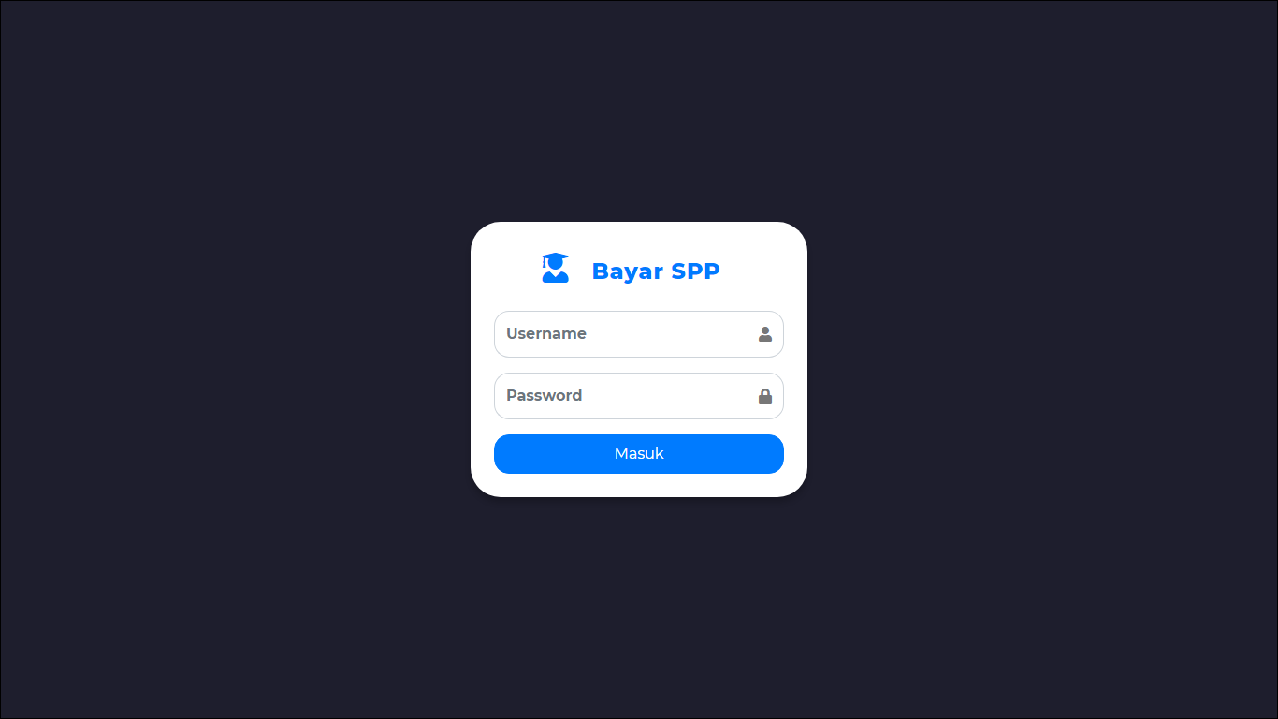

1. Login Admin

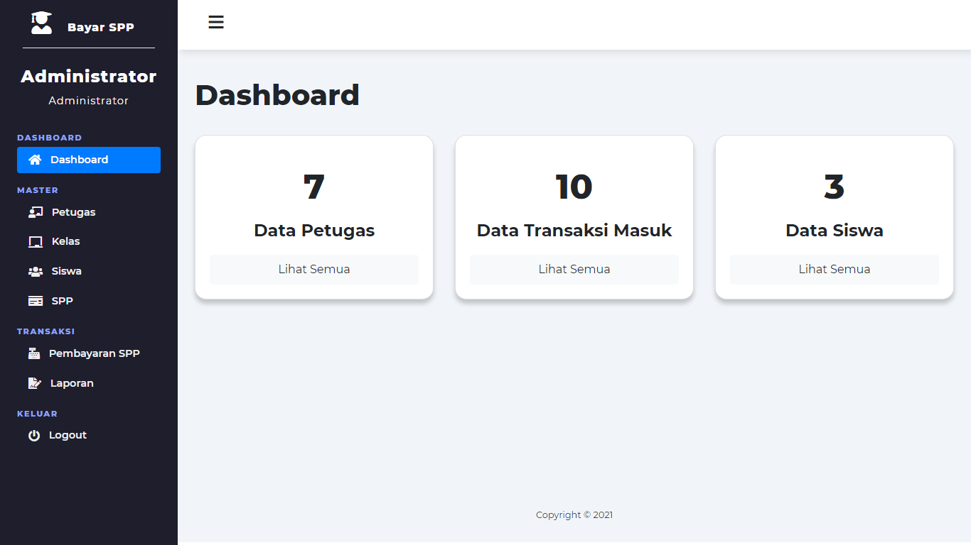

1. Login petugas

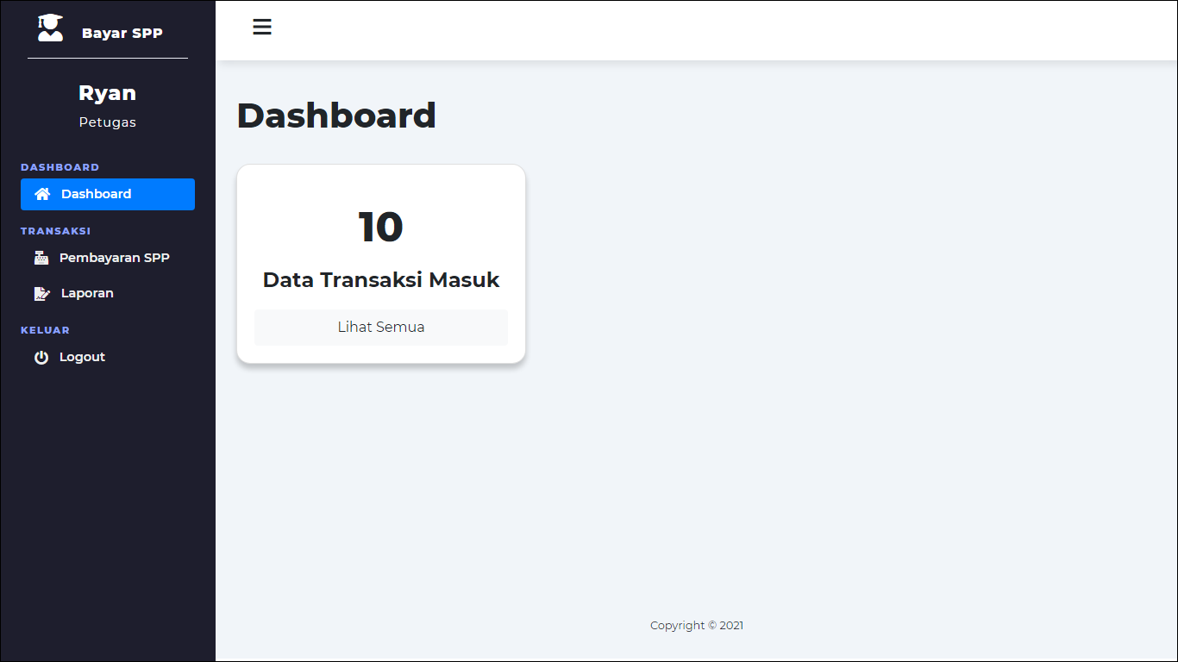

1. Login Siswa (catatan : data siswa dummy langsung lewat db, belum crud. Serta login siswa menggunakan nisn pada table siswa).

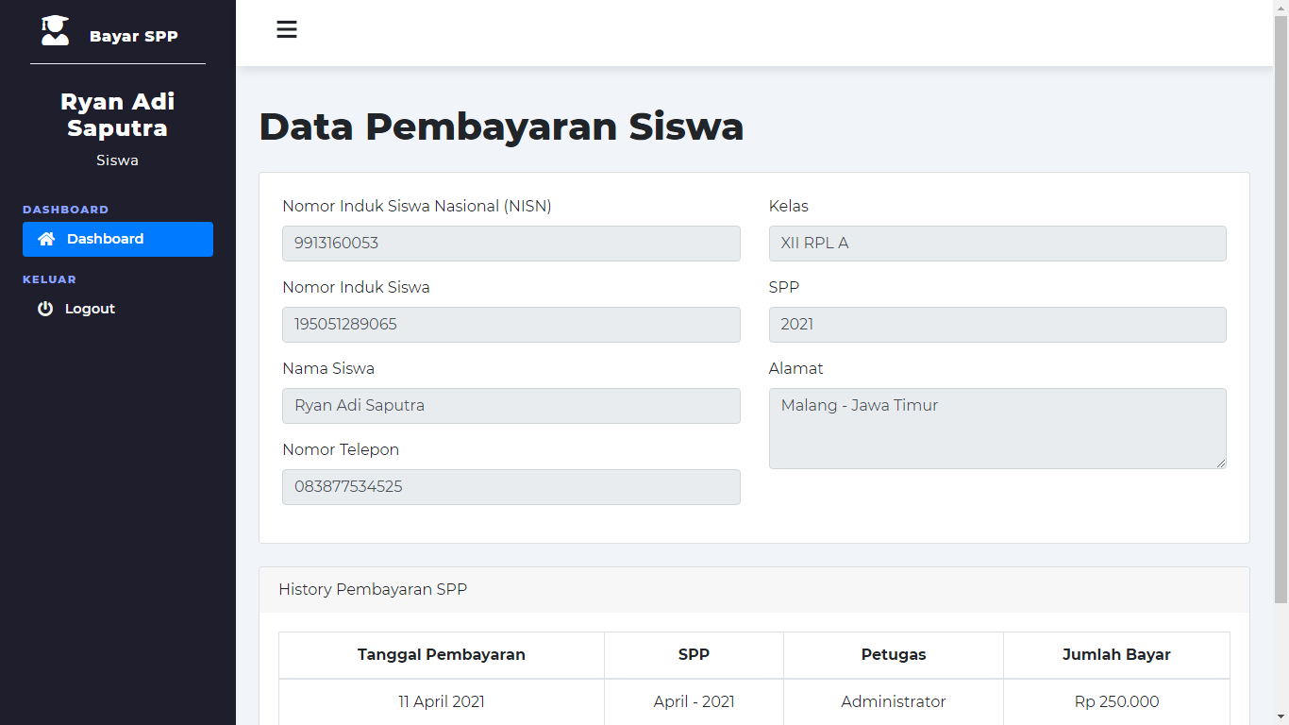

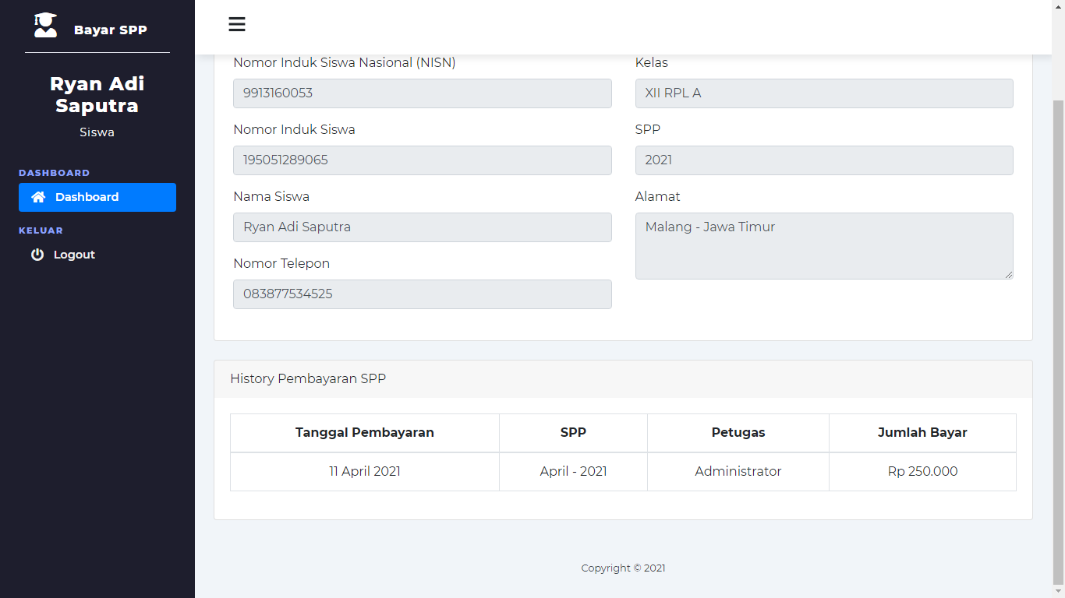

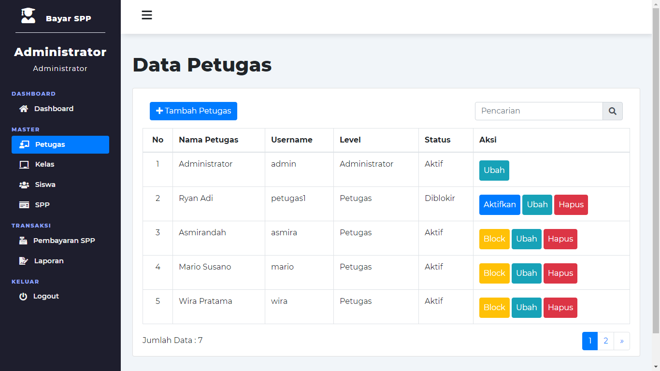 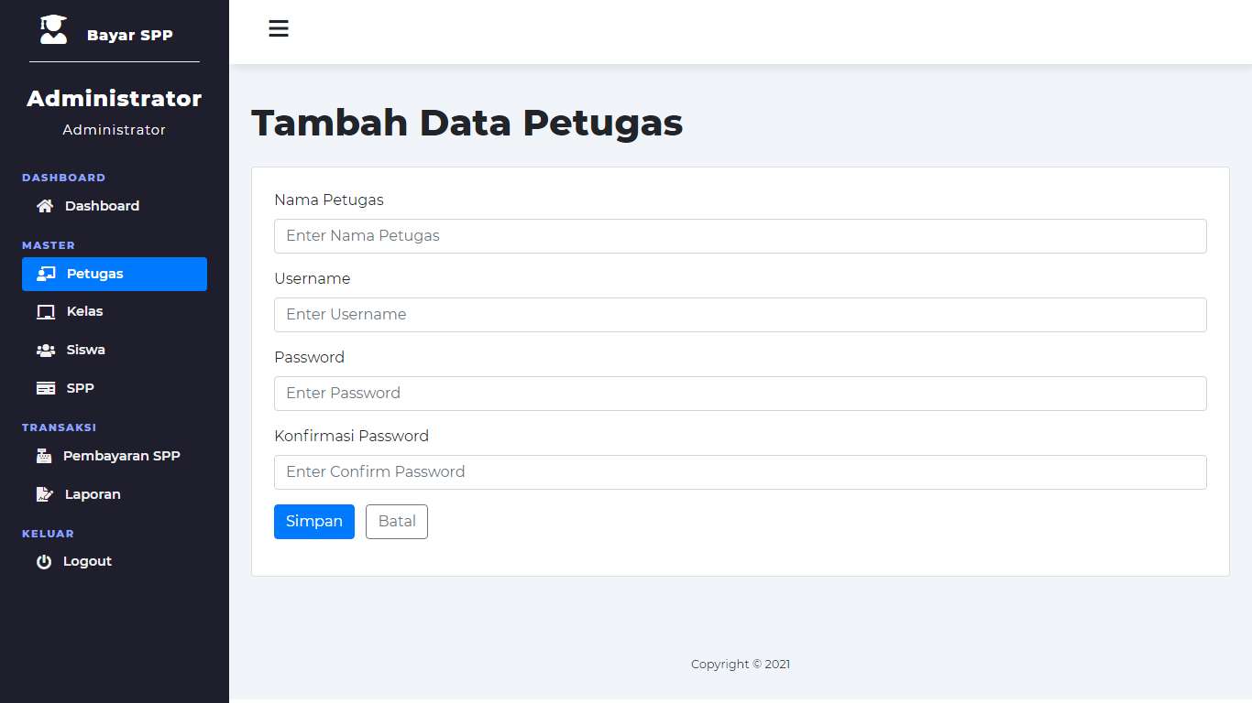 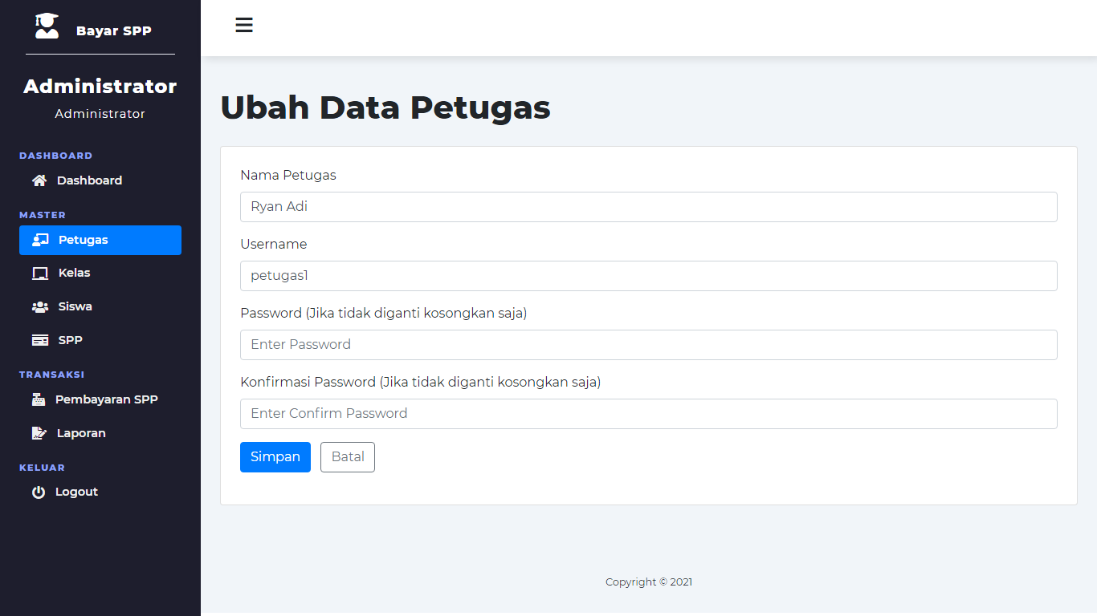

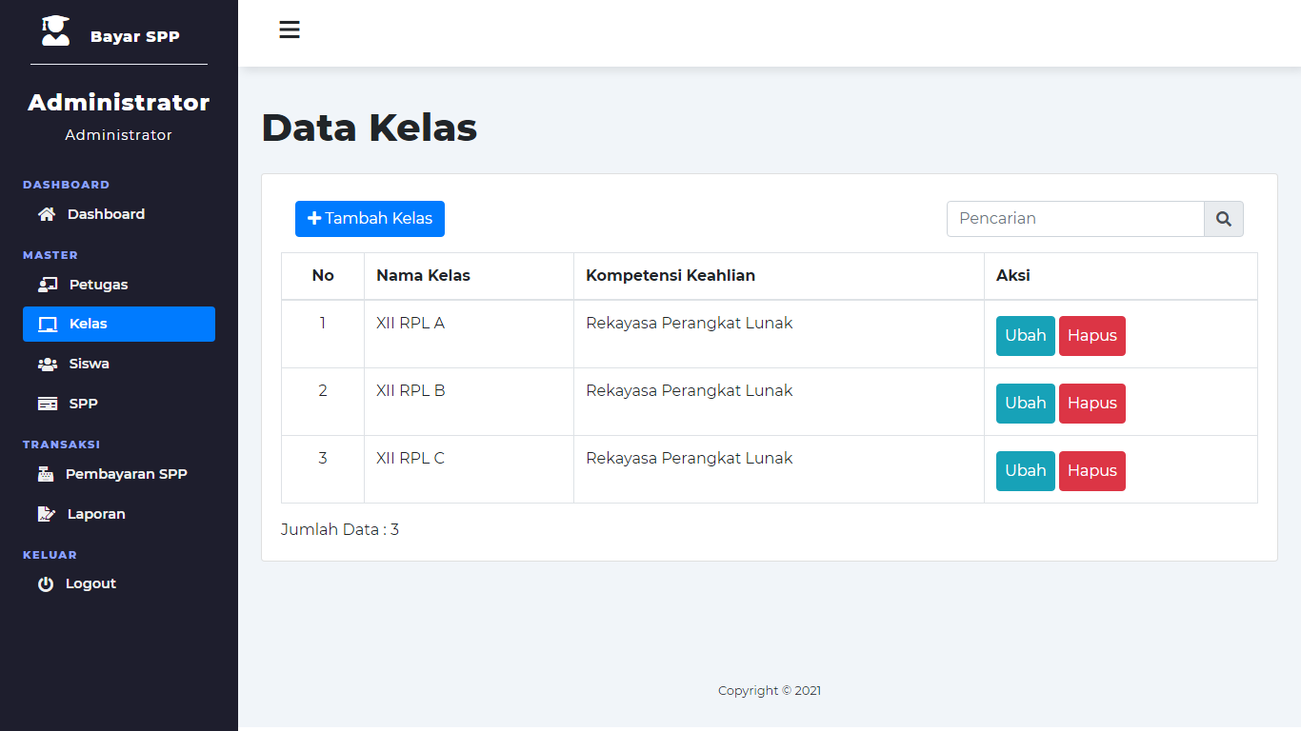

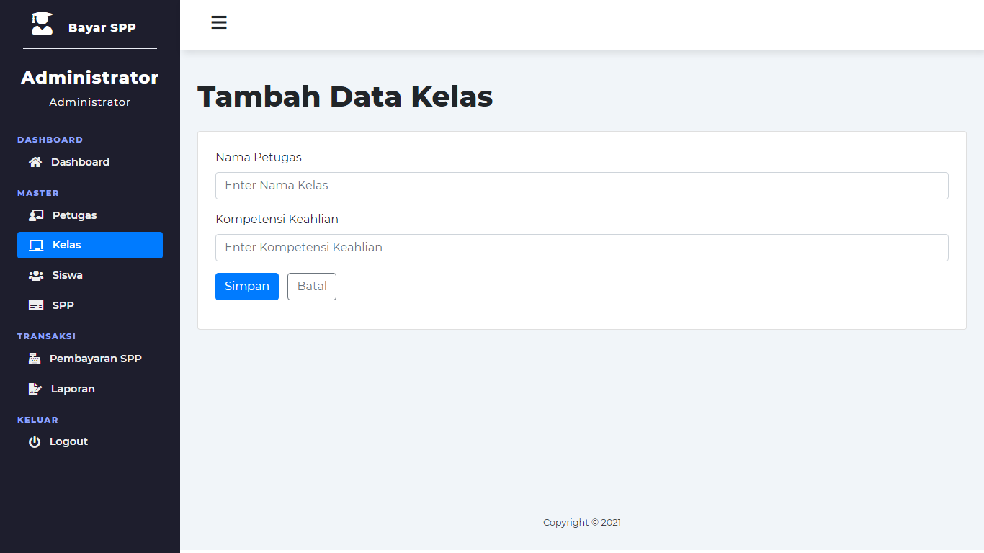

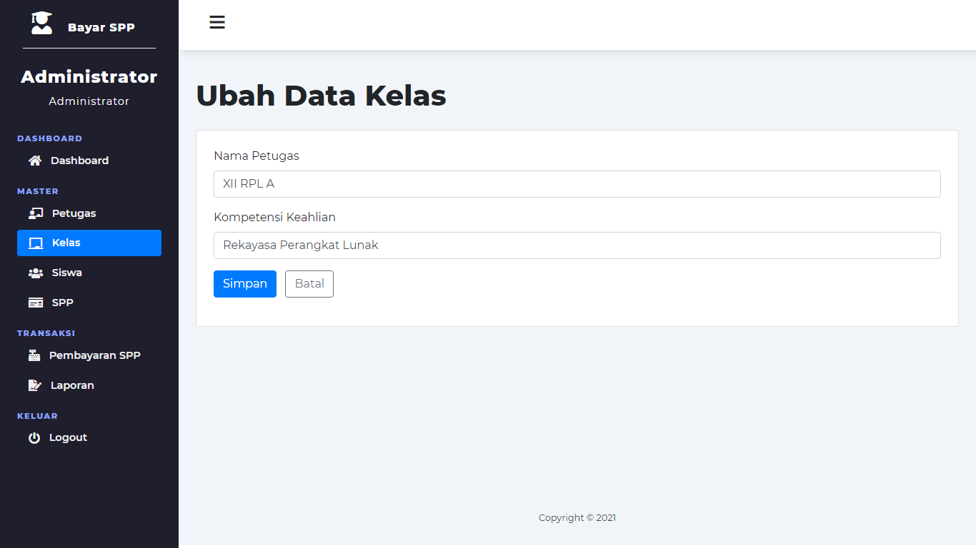

1. Database

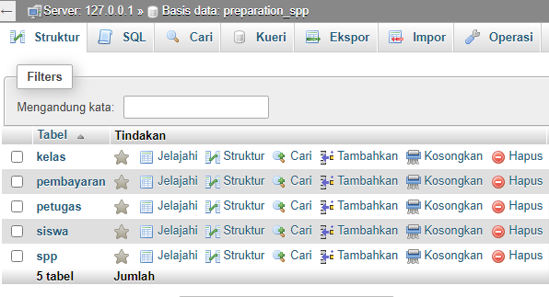

1. Table kelas

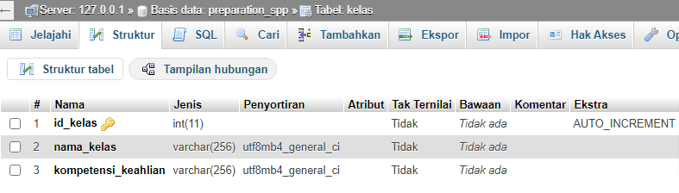

1. Table pembayaran

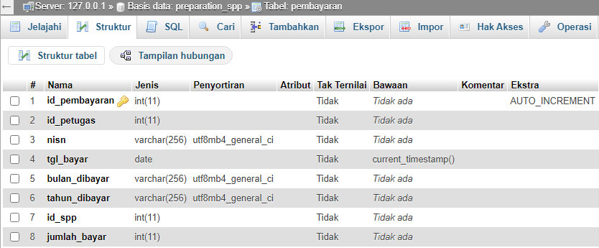

1. Table petugas

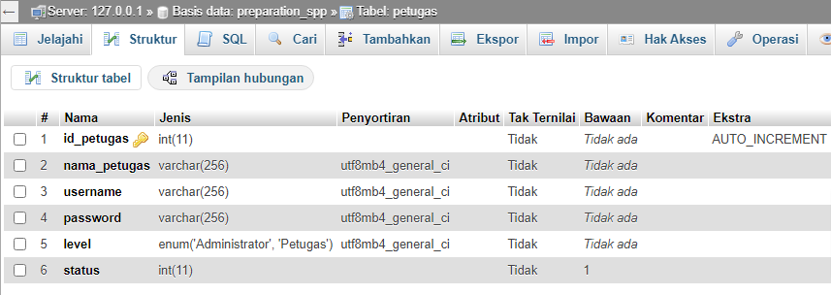

1. Table siswa

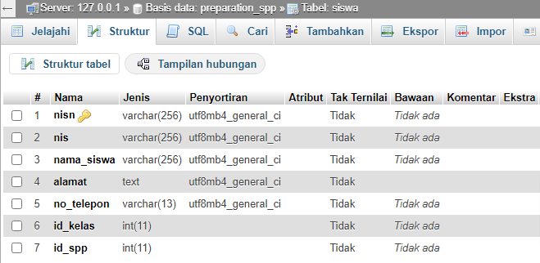

1. Table spp

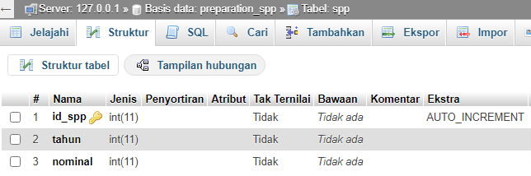

**=== SELAMAT MENGERJAKAN ===**